**Problem 1: (Infinite Algorithm)** The problem with this algorithm is that, some of the steps appear more than once, i.e. step 5 get second number, step 7, get third number, etc. One could shorten the algorithm or flowchart as follows:

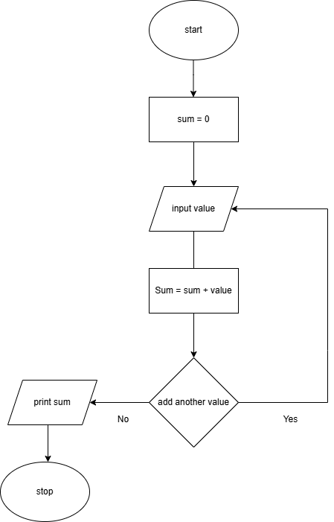

**Problem 2: (Finite Algorithm)** The new list of numbers is given as 26, 49, 498, 9387, 48962, 1, -1. The value –1 is a unique number since all other numbers are positive. This means that the procedure will stop once -1 is encountered.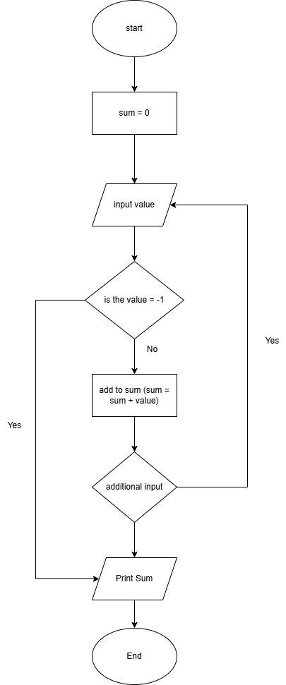

1. Design an algorithm and the corresponding flowchart for finding the sum of the numbers 2, 4, 6, 8, …, n (output: Algorithm and Flowchart)

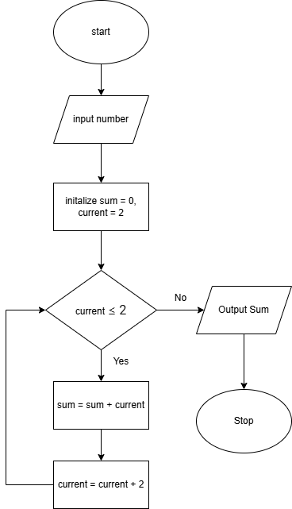

1. Write an algorithm to read 100 numbers and then display the sum.

Start

Sum = 0

For i = 1 to 100 do

Num = READ_NUMBER()

Sum = sum +num

End for

Display “The sum is: “,sum

1. Write an algorithm to read two numbers then display the largest.

Start

Input = number1

Input = number2

If number1>number2

Display number 1

Else

Display number2

end

1. Write an algorithm to read two numbers then display the smallest

Start

Input = number1

Input = number2

If number1>number2

Display number 2

Else

Display number1

end

1. Write an algorithm to read three numbers then display the largest.

Start

Input = number1

Input = number2

Input = number3

If number1>number2>number3

Print number1  
Elseif  
If number2>number1>number3  
Print number2  
Else  
If number3>number1>number2  
Print number3

End

1. Write an algorithm to read 100 numbers then display the largest.

Start

Set largest

Input = num1

Largest = num

For 1 from 2 to 100()

Input = num2

If num1>num2

Print largest

End